(7082CEM)

Coursework
Demonstration of a Big Data Program

MODULE LEADER: Dr. Marwan Fuad
Student Name: Sunggu Choi
SID: 8498810

Car Accidents Analytics and Prediction Modelling

DARFT – REMOVE THIS BEFORE SUBMIT

I can confirm that all work submitted is my own: Yes

Introduction

In modern world, amount of data growing tremendously. Data is becoming an essential resource to understand the society and advancing technology. As part of technology, Machine Learning has introduced (ML). ML is a framework mimic how human learning a certain object. Such as learning how to spark a language is involving the similar process. However, implementing these steps to a computer is challenging. The system should have a dedicated component to accelerate computation and software as well. To tackle this problem a variety of ML techniques are introduced. Spark will be used in this report.
In this report, it will explore technical aspect of setting up PySpark environment and utilising it for Machine Learning project. The outcomes of ML project and its subprocesses will be discussed on the report.
At the beginning of report, it will start with a detail explanation of essential software that would be used during the project and demonstration of installing them. Software will be involved with three main software: PySpark, Pandas and TensorFlow.
For the research, a dataset was required for the project. Based on United States Car Crush dataset, it contains a car crush record during 2016 to 2019 with various factors indicating the road condition and description. However, during the process a number of columns has to be removed for data cleaning. It will be discussed in this section.
The paper has structured as following orders: the objectives and tasks will be discussed at first. Second, the main part of the code and detailed explanation will be presented. The source code produced during the project is available on GitHub and included in the Appendix.
Before starting actual date processing, data cleaning was performed. After that, a visualised data explanation described for data analysis. The data cleaning has been made on PySpark and visual representation made from Pandas and Python library Matplotlib. Next, a simple ML model was deployed for finding how a factor will be causing a car accident.
At the end of the paper, the evaluation part will be discussed. In terms of the how it implemented and what was has been made and what could be more improved.

Software Review

Spark
Spark is a unified analytics engine for large-scale data processing (Apache Spark™ - Unified Analytics Engine for Big Data, n.d.). The framework is optimised for big data processing. From loading a data and sending SQL queries makes much simpler. It enables to process large volume of data from wide range of data sources. This makes large data processing much easier and faster.
Spark has a range of built-in libraries such as Spark SQL (For structured SQL), Spark Streaming, MLlib (Machine Learning) and GraphX. Allows to work seamlessly between the components. To beyond these libraries, Spark can be connected to other external libraires so enables to maximalise data processing capacity.

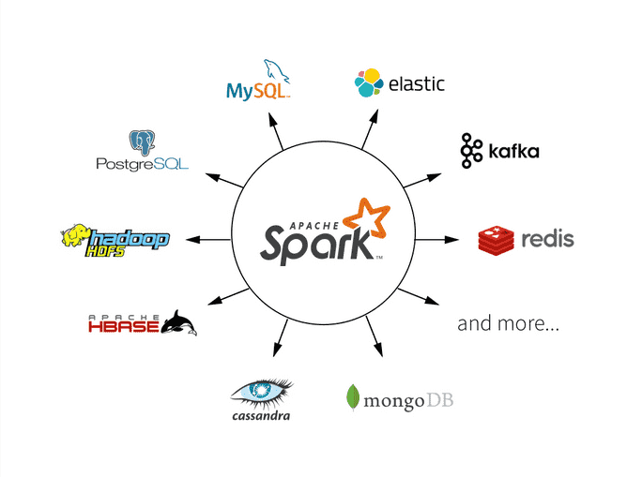
Figure 1 - Spark
Spark can be deployed most computing environment, it unnecessary be located in a traditional storage. As a result, the system can be existing any place, such as

Can be used with cloud services such as Azure Storage, also it supports distributed file system such as Apache Hadoop, Apache Casandra so allows to use its each feature.

References
Spark.apache.org. n.d. Apache Spark™ - Unified Analytics Engine For Big Data. [online] Available at: <https://spark.apache.org/> [Accessed 22 October 2020].

Shaikh, E., Mohiuddin, I., Alufaisan, Y. and Nahvi, I., 2019. Apache Spark: A Big Data Processing Engine. 2019 2nd IEEE Middle East and North Africa COMMunications Conference (MENACOMM),.

Databricks. n.d. Apache Spark™ - What Is Spark. [online] Available at: <https://databricks.com/spark/about> [Accessed 22 October 2020].

